Software Development And Documentation Project
Smart Transportation System Documentation
---------------------------------------------------------------------------------------------------------------------
Members
Noor Shananeer 202310081
Sarah Shahrour 202311299
Course
Software Development And Documentation
Instructor
Ahmad Hassan
Section
Section 1
Semester
Second Semester 2025/2026

1. User Stories
1.1Student
- As a student, I want to log in so that I can access the application.
- As a student, I want to reset my password in case I forget it.
- As a student, I want to open the dashboard and choose between going to MEU or leaving it.
- As a student, I want to check the bus timetables so I know when the buses leave.
- As a student, I want to see the bus routes on the map so that I can understand the bus's destination.
- As a student, I want to track the bus route in real time so I know when it's approaching me.
- As a student, I would like to update my profile information as needed.
- As a student, I want an easy way to communicate with the driver or support team.
- As a student, I would like to evaluate the service based on my experience.
1.2Driver
- As a driver, I want to log in so I can see my tasks.
- As a driver, I want to reset my password if I can’t access my account.
- As a driver, I would like to display my dashboard to manage my business.
- As a driver, I want to change my status (active or inactive) based on my availability.
- As a driver, I want to review my assigned trips to know what to do next.
- As a driver, I want to easily start a trip from the app.
- As a driver, I want to use the navigation system during the trip so I don't miss any stops.
- As a driver, I want to update my personal information if there are any changes.
- As a driver, I want to report any problems during the trip quickly.
1.3Admin
- As an administrator, I want to log in to control the system.
- As an administrator, I want to log out securely after I finish my work.
- As an administrator, I want to see all buses in one place.
- As an administrator, I want to edit bus data as needed.
- As an administrator, I want to view driver information to manage them properly.
- As an administrator, I want to assign trips and tasks to drivers.
- As an administrator, I want to easily create and update schedules.
- As an administrator, I want to track buses in real time to see what's happening.
- As an administrator, I want to receive alerts in case of any problems.
- As an administrator, I want to generate reports to evaluate the system.
- As an administrator, I want to update my profile and settings.
2.Use Cases
2.1 Student Use Case
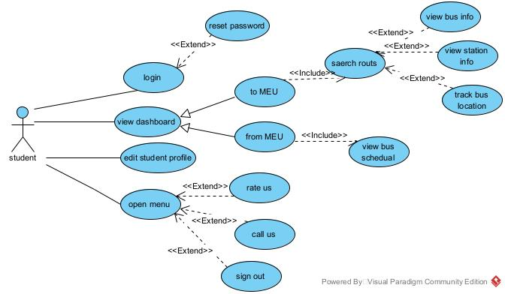
2.2 Driver Use Case
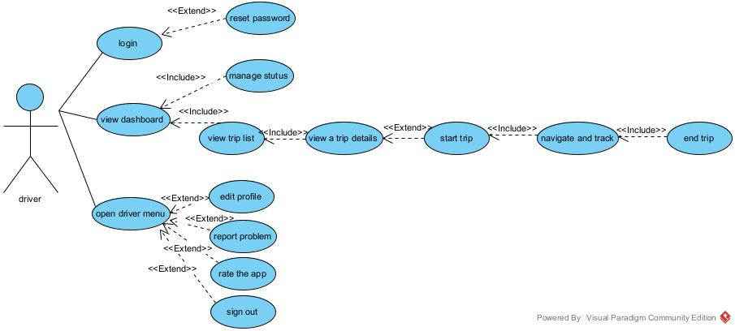

2.3 Admin Use Case
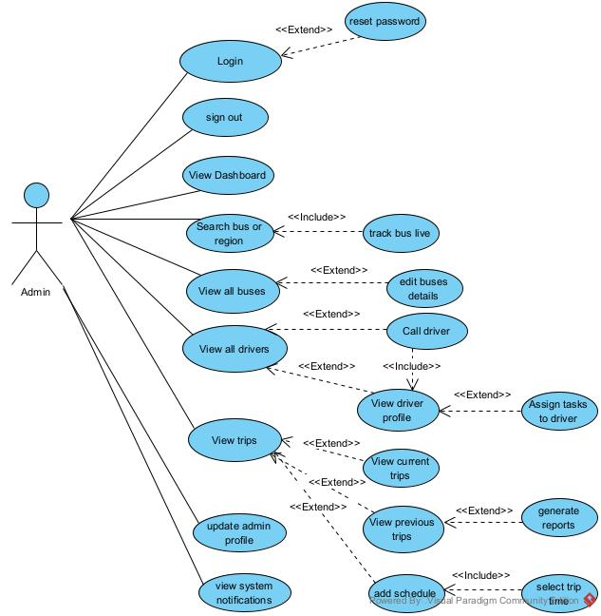
3.4 Use Case Description

1. log in
Use Case ID | UC001
Use Case Name | log in
Created By | Sarah Shahrour
Date Created | 25/4/2026
Brief Description | Allows the student to securely access the application using their username and password.
Primary Actor | Student
Secondary Actor | -
Pre-condition | The user has a valid account (username and password).
Post-Condition | The student is redirected to the dashboard.
Main Flows | 1. The student opens the app.  2. The login screen appears.  3. The student enters their username and password.  4. The student clicks the “Login” button.  5. The system verifies the credentials.  6. If correct, the system shows the dashboard.
Alternative Flow | 3a. If credentials are invalid:  • System displays error message: “Invalid username or password”.  • Returns to step 2.

2. View Buses Schedule
Use Case ID | UC002
Use Case Name | View Buses Schedule
Created By | Noor shananeer
Date Created | 25/4/2026
Brief Description | Displays a full schedule of buses leaving MEU.
Primary Actor | Student
Secondary Actor | -
Pre-condition | “From MEU” option is selected.
Post-Condition | The bus schedule is displayed.
Main Flows | 1. The student clicks on the schedule option.  2. The full list of routes, areas, and times is shown.

3. Add Schedule
Use Case ID | UC003
Use Case Name | Add Schedule
Created By | Sarah Shahrour
Date Created | 25/4/2026
Brief Description | Allows the administrator to add a new trip schedule including trip time, destination, and bus number.
Primary Actor | Admin
Secondary Actor | -
Pre-condition | • The administrator must be logged in.  • Bus and destination data must be available.
Post-Condition | The schedule is saved and added to the list of trips.
Main Flows | 1. The administrator opens the “Add Schedule” page.  2. Enters trip details:  • Destination  • Trip time  • Bus number  3. Click the “Add” button.  4. The system saves the schedule and confirms success.
Alternative Flow | 2a. Incomplete fields:  a. The system displays a warning for missing information.  b. The administrator is prompted to complete the required fields.

4. View All Buses
Use Case ID | UC004
Use Case Name | View All Buses
Created By | Noor Shananeer
Date Created | 25/4/2026
Brief Description | Displays a list of all buses with relevant details.
Primary Actor | Admin
Secondary Actor | -
Pre-condition | Admin must be logged in.
Post-Condition | The bus list is shown on the table.
Main Flows | 1. Admin selects “Buses” from the menu.  2. The system shows a table with bus details: number, route, time, capacity, notes, etc.

5.view trip list
Use Case ID | UC005
Use Case Name | View trip list
Created By | Sarah Shahrour
Date Created | 25/4/2026
Brief Description | Allows the driver to view the list of all assigned trips.
Primary Actor | Driver
Secondary Actor | -
Pre-condition | The driver must be logged in and on the dashboard screen.
Post-Condition | A list of all upcoming or active trips is displayed.
Main Flows | 1. Driver navigates to the trip list section from the dashboard.  2. System fetches all assigned trips for the driver.  3. Trips are displayed with summary info (date, route, status).  4. Driver may select a trip to view its details.
Alternative Flow | 2a. If there are no assigned trips:  • System shows a message: “No trips assigned.”

6. Start Trip
Use Case ID | UC006
Use Case Name | Start Trip
Created By | Noor Shananeer
Date Created | 25/4/2026
Brief Description | Begin the selected trip and activate trip tracking.
Primary Actor | Driver
Secondary Actor | -
Pre-condition | A trip must be selected.
Post-Condition | Trip status is set to “In Progress”.
Main Flows | 1. Driver presses “Start Trip”.  2. System marks trip as started.  3. Navigation and tracking begin.

3. Functional Specification
1. Actors
- Student
-Driver
-Administrator
2. Student Functional Specifications
2.1 Authentication
FR1 – Student Login
Description: Allow students to log in using username and password
Inputs: Username, Password
Process: The system validates the entered credentials
Output: Access granted or error message
FR2 – Forgot Password
Description: Allow students to reset password via university email
Inputs: University email
Process: The system sends a verification code, validates it, then allows password reset
Output: Password reset confirmation
2.2 Dashboard
FR3 – View Dashboard
Description: Display dashboard after successful login
Output: Two options are shown (To MEU, From MEU)
2.3 Transportation Features
FR4 – View Bus Schedule (From MEU)
Description: Display bus schedules provided by the administrator
Output: Bus number and schedule details
FR5 – Interactive Map (To MEU)
Description: Display an interactive map with routes and stations
Features: Route selection, station locations, bus details
2.4 Profile and Menu
FR6 – Manage Profile
Description: Allow students to edit personal information
Editable fields: Student number, major, home location, profile picture
Menu options: Rate Us, Call Us, Sign Out
3. Driver Functional Specifications
3.1 Authentication
FR7 – Driver Login
Description: Allow drivers to log in using valid credentials
FR8 – Driver Forgot Password
Description: Allow drivers to reset password via personal email
3.2 Dashboard and Status
FR9 – Driver Dashboard
Description: Display dashboard and allow driver to change status
Options: Active, Inactive
3.3 Trip Management
FR10 – View Assigned Trips
Description: Display assigned trips
Action: Driver can start a trip using “Begin Trip”
FR11 – Trip Tracking (To MEU)
Description: Provide real-time tracking during the trip
Details: Navigation, next station, passenger list
FR13 – Trip Tracking (From MEU)
Description: Track trip until all stations are completed
3.4 Profile and Support
FR12 – Driver Profile
Description: Allow drivers to edit personal information and report issues
4. Administrator Functional Specifications
4.1 Authentication
FR14 – Admin Login and Password Recovery
Description: Allow administrators to log in and reset password
FR15 – Logout
Description: Allow administrators to log out securely
4.2 Dashboard and Monitoring
FR16 – System Overview
Description: Display real-time system data
Details: Bus locations, routes, stations
FR17 – Interactive Map
Description: Display live map with bus tracking
Features: Zoom and pan
FR18 – Search
Description: Allow searching for buses or regions
4.3 Bus Management
FR19 – View Bus Data
Description: Display all bus details
Details: Bus number, destination, capacity, passenger count
FR20 – Edit Bus Details
Description: Allow administrators to update bus information
4.4 Driver Management
FR22 – View Drivers
Description: Display list of drivers
FR23 – Driver Profile
Description: Display detailed driver information
FR24 – Call Driver
Description: Allow administrator to call drivers
FR25 – Assign Tasks
Description: Assign and modify driver tasks
4.5 Trip Management
FR26 – View Ongoing Trips
Description: Display current trips with full details
FR27 – View Past Trips
Description: Display historical trip records
FR28 – Add Trip Schedule
Description: Allow administrators to create new schedules
4.6 Profile and Settings
FR29 – Admin Profile Management
Description: Allow administrators to edit profile information
FR30 – System Settings
Description: Configure system settings and notifications
4.7 Monitoring and Alerts
FR31 – Real-Time Updates
Description: Display live operational data
FR32 – Alerts
Description: Notify administrators of critical issues
Examples: Fuel issues, delays, violations
4.8 Reporting
FR33 – Reports and Analytics
Description: Generate performance and historical reports
4.9 Security
FR34 – Security Controls
Description: Apply security measures
Includes: Encryption, password policies, audit logs

4.Version Control (Git/GitHub) Plan
4.1 Introduction
This project uses Git and GitHub as version control tools to manage project documentation, track changes, and support collaboration between team members during the development of the Smart Transportation System documentation project.
4.2 Purpose of Using Git and GitHub
Git and GitHub are used in this project for the following purposes:
- Tracking all modifications made to project files
- Saving multiple versions of documentation.
- Allow collaboration between team members.
- Preventing accidental file or data loss.
- Restoring previous versions when needed.
- Managing project updates professionally.
4.3 Repository Management
A GitHub repository was created to store and manage all project files online.
The repository contains:
- Project Proposal
- User Stories
- Use Cases
- Functional Specifications
- Diagrams and Documentation Files
Repository Name: Smart Transportation System
4.4 Team Collaboration
The project work was divided between team members to support collaboration using GitHub.
Noor Shananeer Responsibilities
- User Stories
- Use Case Descriptions
- Documentation Updates
- Formatting and Final Review
Sarah Shahrour Responsibilities
- Functional Specifications
- Diagrams and Workflow Design
- Formatting and Final Review
- Project Organization
4.5 Git Workflow
The following workflow was used throughout the project:
1. Create a GitHub repository.
2. Upload project files.
3. Edit and update documentation files.
4. Create commits for each major update.
5. Push updated files to GitHub.
6. Maintain the latest version of the project in the main branch.
  - Commit Examples
Examples of commit messages used during the project:
-Initial project upload
-Updated documentation files
-Added GitHub version control plan
-Final project update
4.7 Benefits of Version Control
Using Git and GitHub provides several advantages:
- Improved teamwork and collaboration
- Easier project organization
- Secure file storage
- Easy project history tracking
- Ability to restore previous versions
- Professional project management
4.8 Conclusion
Git and GitHub helped organize the Smart Transportation System documentation project effectively. The version control process improved collaboration, maintained project history, and ensured proper management of all project documents and updates.

